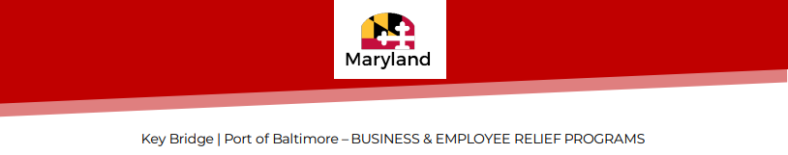

Supporting documentation is required to complete all loan and grant application requests. Please provide the following documents outlined in the checklist below:
Documentation MUST provide proof of loss of revenue or increase in expenses.

Name of Business/Applicant: __________________________________________

Business Address: _________________________________________________

Items | Received (Y/N) | Date
- Financial profit and loss statements for 2023
- Financial profit and loss statements for 2024 year-to-date showing loss of revenues and/or increased expenses since the collapse of the Francis Scott Key Bridge beginning on March 26, 2024.
- Provide copies of the last 2 years of completed federal tax returns (All pages required)
- Any insurance documentation detailing business interruptions.
- Proof of business ownership - organizational documents (articles of incorp., operating agreement, or by-laws)
- Proof of Good Standing from SDAT
- W9

Applications will remain incomplete and unable to be processed until all documents have been received.

Please upload documentation into the online portal, or send documents by email to portrecovery.dhcd@maryland.gov

*GRANT AND LOAN ELIGIBILITY/RESTRICTIONS*
• Businesses with 500 or fewer Maryland employees are eligible. • Must have a minimum of 2 employees • Funds will be used to address revenue reductions and/or operating expense increases, the replacement of which are critical to the business continuity of operations, and which were incurred beginning on March 26, 2024. • Proof of loss of revenue or increased expenses due to bridge collapse/reduction in Port operations • Grant requests must be located within 5 miles of the Key Bridge and in a Priority Funding Area • Loan requests have NO geographic limitation • Must be registered and in good standing with the Maryland Department of Assessments and Taxation (SDAT). • Non-profit organizations are not eligible.

