Maryland Business Recovery
Façade Improvement Program Application

Maryland Department of Housing and Community Development
Division of Neighborhood Revitalization

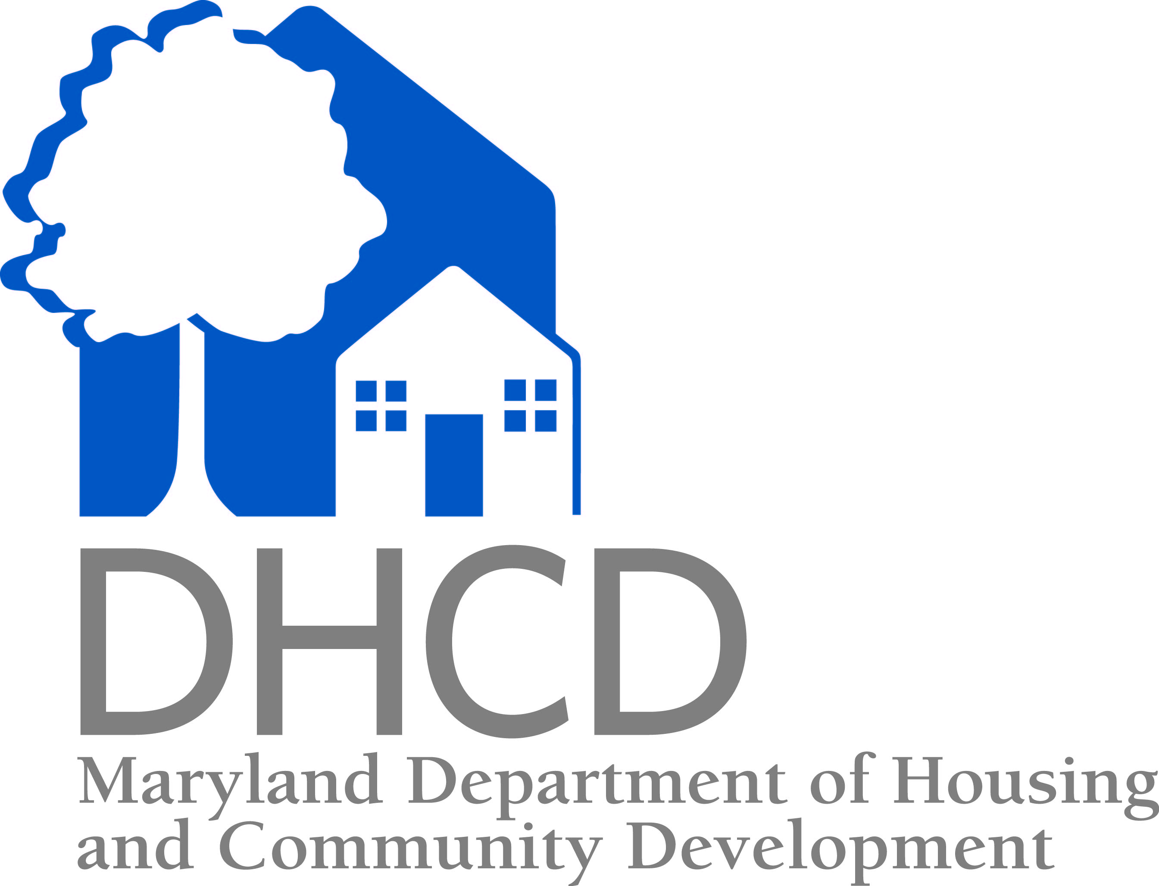

Application Round 1 Deadline: Tuesday, December 15, 2015
Larry Hogan
Governor

Ellington E. Churchill, Jr.
Deputy Secretary
Boyd K. Rutherford
Lt. Governor

Kenneth C. Holt
Secretary

Maryland business recovery

façade improvement program

In support of commercial properties and surrounding neighborhoods affected by civil unrest in the spring of 2015, the Maryland Department of Housing and Community Development has created a façade improvement grant program. Grant funds will be used for architectural designs, workforce development services and construction services to improve building and storefront exteriors, improving the visual appeal and marketability of individual buildings and commercial districts affected by civil unrest in the spring of 2015.

The purpose of this application is to identify Maryland-based small businesses and non-profit organizations located in commercial buildings or districts that were damaged physically and/or economically due to civil unrest.

Application information

ELIGIBILe applicants
- Maryland-based small businesses, non-profit organizations or property owners located in Baltimore City may apply (tenants must have permission of the property owner)
- Businesses must be in good standing with the State of Maryland

Priorities
Funds are limited; therefore façade projects will be prioritized based on their potential to revitalize communities and attract and retain small businesses in commercial districts. Other priorities include:
- Participants of the Maryland Business Recovery Loan Program
- Storefront businesses that experienced physical damage or financial hardship as result of the civil unrest
- Businesses/organizations/properties located in Baltimore City Main Streets and commercial districts

Funding Availability
- Up to $10,000 per business/property (amount based on scope of work)
- Larger grants may be available but any funds over $10,000 would have to be matched 1:1 by the business and/or property owner. For example, a grant of $15,000 would require a minimum $5,000 contribution from the business and/or property owner. Since funds are limited, larger grants will be kept to a minimum but will be considered for projects that will have a larger scope and impact.

Application Rounds
Applications can be submitted at any time before the deadline (December 15, 2015); however since funds are limited, applications will be reviewed in rounds and funds for façade projects will be allocated based on revitalization impact. Additional rounds will be announced if funds remain after Round 1.

GRANT TERMS
- Conceptual and architectural designs and scopes of work will be developed in partnership with and approved by the business/property owner, the Department and one or more non-profit partners selected by the Department
- Façade designs and scopes of work must also be approved by the Maryland Historical Trust and, if required, local design review committees, prior to construction commencing
- Architectural design and construction work will be performed by a non-profit organization or one of its partners identified by the Department

Examples of POTENTIAL PROJECTS
Façade improvement projects could include any of the following in their project scopes:
- Exterior painting, re-siding, or professional cleaning
- Restoration of exterior finishes and materials
- Masonry repairs
- Removal of architecturally inappropriate or incompatible exterior finishes and materials
- Restoration of architectural details or removal of materials that cover architectural details
- Repair or replacement of windows and doors
- Window and cornice flashing and repair
- Canopy or awning installation or repair
- Murals or other artist fabricated improvements
- Installation or repair of exterior signage
- Removal of barriers to access the building from outside for people with disabilities
- Exterior lighting
- Wall, window, hanging and monument signs advertising the business name and identity
- Other capital improvements as approved

Note: All of the above work must be architecturally appropriate and approved by the Maryland Historical Trust.

restrictions
The following types of projects and activities will not be considered for funding, unless the project includes another eligible business type (like groceries, restaurant, etc.):
- Adult bookstores, adult video shops, other adult entertainment facilities, gambling facilities, gun shops, massage parlors, pawn shops, tanning salons, or tattoo parlors
- Home-based businesses

APPLICATION REVIEW PROCESS AND PROGRAM IMPLEMENTATION
- Property/business owners interested in being considered for a façade improvement must submit an application (pages 4-7) to the Department.
- After application submission, the Department will determine if the property listed in the application meets one or more of the agency’s priorities listed on page 1.
- If the property is selected for a façade improvement, the Department and one or more of its non-profit partners will meet with the business and/or property owner to discuss the scope of work, budget and timeline for the project. A design and scope of work for the façade improvement will then be provided to the business and/or property owner pro-bono.
- Prior to project commencement, all parties, including business and/or property owners, non-profit partners and the Department, must execute a multi-party agreement detailing the design and scope of work.
- If the business and/or property owner decides he/she does not want the Department or its non-profit partners to proceed with the scope of work, the business and/or property owner must notify the Department in writing prior to executing the agreement.
- Once the design and scope of work are approved, the Department will work with its selected non-profit partners to complete the façade improvements.
- The Department will pay the non-profit partner directly for the construction services performed.
- For projects more than $10,000 in which the property and/or business owner is making a financial contribution, the property and/or business owner will pay the non-profit partner directly for the construction services performed prior to the commencement of the project.

APPLICATION SUBMISSION
A complete application consisting of the items on the Required Documentation Checklist (see pg. 4) must be submitted before an application can be fully reviewed. If the application for the façade improvement is approved, additional documentation may be necessary.

Applications can be submitted at any time before the deadline (December 15, 2015); however since funds are limited, applications will be reviewed in rounds and funds for façade projects will be allocated based on revitalization impact. Additional rounds will be announced if funds remain after Round 1.

FOR ADDITIONAL INFORMATION
Please contact:
Mary Kendall, Program Officer
Phone: 410-209-5810
Email: Mary.Kendall@maryland.gov
Maryland Department of Housing and Community Development
2 North Charles Street, Suite 450
Baltimore, Maryland 21201
REQUIRED DOCUMENATION CHECKLIST
This documentation is needed for all façade improvement projects requested from the Maryland Business Recovery Façade Improvement Program. Complete information is necessary to process your request.

Attach the following with your application:

1. Completed application (pages 4, 5 and 6) and signed Waiver and Authorization Form (pages 7 and 8)

2. Photographs of exterior of the building/property

3. Proof of business and/or property insurance if available

4. Proof of business ownership - organizational documents

5. Proof of site control (such as a copy of a deed or a lease agreement)

6. Evidence of good standing with the State if applicable (business and property owner)
*To verify a business entity’s good standing, go to SDAT website: http://sdat.dat.maryland.gov/ucc-charter/

*If any of the above documentation has already been submitted to the Department via the
Maryland Business Recovery Loan Program, please write “MBR” in the checkbox.

Please contact Mary Kendall, 410-209-5810 or Mary.Kendall@Maryland.gov with questions regarding these application requirements.

DEPARTMENT OF HOUSING AND COMMUNITY DEVELOPMENT
2 North Charles Street, Suite 450
Baltimore, MD 21201
410-209-5800
FAX 410-685-8270

APPLICATION FOR FAÇADE IMPROVEMENT PROGRAM
(Please Print Clearly or Type)
Date: ____________

- Applicant Information
Applicant Name:
Applicant Address:
Telephone No. (Home):
Telephone No. (Cell):
Email Address:
- Business Information
Legal Business Entity Name:
Business Name, if different from entity name:
Address of Business:
Business Telephone No.:
Business Email Address:
Federal I.D. No.:
- Property and/or Business Insurance Information
Is the property and/or building insured? (yes/no)
Is the business insured? (yes/no)
Name of Insurance Company (if available):
Contact/Agent Name:
Contact/Agent Tel. No.:
Policy Number:
- Property Ownership Information
Name of Building/Property Owner, if other than applicant:
Address of Building Owner:
Telephone No. of Building Owner:
Email Address of Building Owner:

PROJECT INFORMATION
- Provide a description of the desired façade improvement/s:

- How much do you estimate the total façade improvement to cost?

- If the scope of work for the façade improvement is more than $10,000, are you willing and/or the property owner able to contribute funds towards the cost of the project?

- Why would you like to have this work completed? Why is this façade improvement important to your business and community?

- Describe any financial hardship to your business or physical damage to your property experienced as result of the civil unrest in April 2015?

- If the applicant is not the property owner, does the applicant have permission to make improvements to the exterior of the building? (yes/no)

Waiver and Authorization Form

The undersigned authorizes the Department of Housing and Community Development (the “Department”) to make such inquiries as necessary, including, but not limited to, credit inquiries in order to verify the accuracy of the statements made by the applicant and to determine the creditworthiness of the applicant.

In accordance with Executive Order 01.01.1983.18, the Department advises you that certain personal information is necessary to determine your eligibility for financial assistance. Availability of this information for public inspection is governed by Maryland’s Public Information Act, State Government Article, Section 10-611 et seq. of the Annotated Code of Maryland (the “Act”). This information will be disclosed to appropriate staff of the Department or to public officials for purposes directly connected with administration of this financial assistance program for which its use is intended. Such information may be shared with State, federal or local government agencies, which have a financial role in the project. You have the right to inspect, amend, or correct personal records in accordance with the Act.

The Department intends to make available to the public certain information regarding projects recommended for reservation of funds by the Façade Improvement Program. The information available to the public will include the awardee’s name; the name, location, and description of the project; and the amount of financial assistance. This information may be confidential under the Act. If you consider this information confidential and do not want it made available to the public, please indicate that in writing and attach the same to this application.

The Department desires to disclose information about your project to the Maryland General Assembly or other State officials or their staff, local government officials or their staff, other lenders and funding sources, and small business technical advisors. Such information may include your name; photo of the project and/or borrower/recipient; the name, location, and description of your project; the date and amount of financial assistance awarded by the Department; the terms of your financial assistance, including interest rate, repayment obligation, use of funds, and security interest taken; and the sources, amounts, and terms of other funding used to complete your project, including your capital contribution. This information may be confidential under the Act. If you do not want this information made available to the above-referenced parties, you must attach to this application your written objection. You agree that not attaching an objection constitutes your consent to the information being made available to the above-referenced parties and a waiver of any rights you may have regarding this information under the Act.

I have read and understand the above paragraph. Applicant’s Initials:
Anyone who knowingly makes, or causes to be made, any false statement or report relative to this financial assistance application for the purposes of influencing the action of the Department on such application shall be subject to criminal prosecution, a fine of up to $50,000, and/or imprisonment of up to five years.

The undersigned hereby certifies that the information set herein and in any attachments in support hereof is true, correct, and complete to the best of his/her knowledge and belief.

Liability: Applicant releases the Department from, agrees that the Department shall not have any liability for, and agrees to protect, indemnify, and save harmless the Department from and against any and all liabilities, suits, actions, claims, demands, losses, expenses, and costs of every kind and nature, including reasonable attorneys' fees, incurred by, or asserted or imposed against the Department, as a result of or in connection with the Project, except for the gross negligence or willful misconduct of the Department.

I, the Business Applicant and/or Property Owner, have read and understand and agree to the conditions of the Maryland Business Recovery Façade Improvement Program and also consent to the following:
- Work will be performed on the property in accordance with a scope of work developed by the Department and one of its non-profit partners identified by the Department
- Work shall be performed by a non-profit organization or one of its partners identified by the Department
- Any financial contribution made to the project by the business and/or property owner will be paid directly to the non-profit partner identified by the Department
- Prior to project commencement, all parties, including business and/or property owners, non-profit partners and the Department, must execute a multi-party agreement detailing the design and scope of work
- If the business and/or property owner decides he/she does not want the Department or its non-profit partners to proceed with the scope of work, the business and/or property owner must notify the Department in writing prior to executing the agreement

Business Applicant Signature |  | Type Name and Title |  | Date

Property Owner Signature |  | Type Name and Title |  | Date

